Baby Corey_CMFS015H__FCS
Coriolis Flowmeter Calculation Summary |  |  |  |  |  | Quote/Rev No: |  |  |  | -/-
Date: |  |  |  | ‭2023-03-30‬
Company: |  |  |  | -
Project Name: |  |  |  | Fall 2022 Campaign
Service: |  |  |  | -
Sensor Model Name : |  |  |  | CMFS015H
Sensor Model #: |  |  |  | -
Sizing Name: |  |  |  | Baby Corey
Transmitter Model Name : |  |  |  | -
Transmitter Model #: |  |  |  | -
Transmitter Tag(s): |  |  |  | -
Wetted Material: |  |  |  | Alloy C22
Fluid: |  |  |  | GULF COAST NATURAL GAS
Fluid State: |  |  |  | Gas
K(Flow Consistency Index) |  |  |  | -
n(Flow Behavior) |  |  |  | -
Mass Flow Accuracy (+/- % of Rate) |  |  |  | 00.2500
Pressure Drop at Operating Flow |  |  |  | 0.7367 | psig
Velocity at Operating Flow |  |  |  | 16.4796 | m/sec
 |  |  |  | Min | Operating* |  |  | Max |  |  | Design |  | Units
Flow Rate: |  |  |  | 0.2000 | 5.0000 |  |  | 6.0000 |  |  | - |  | kg/hr
Pressure: |  |  |  | - | 150.0000 |  |  | - |  |  | - |  | psig
Process Fluid Temperature: |  |  |  | - | 50.0000 |  |  | - |  |  | - |  | F
Ambient Temperature: |  |  |  | - | 68.0000 |  |  | - |  |  | - |  | F
Density: |  |  |  | - | 0.5192 |  |  | - |  |  | 0.0000 |  | lb/ft3
Viscosity: |  |  |  | - | 0.0103 |  |  | - |  |  | - |  | cP
Gas Only | Base Reference Temperature: |  | F | 60.0000
Gas Only | Base Reference Pressure: |  | psia | 14.6960
Gas Only | Base Reference Density: |  | lb/ft3 | 0.0440
Process Connection: |  |  |  | -
Process Connection Pressure Rating: |  |  |  | -
@Temperature: |  |  |  | 50.0000 F
Flow Rate | kg/hr | Mass Flow Accuracy (+/- % of Rate) |  | Pressure Drop* | psig |  | Velocity at Operating Flow |  | m/sec |  |  | Re
6.0000 |  | 00.2500 |  | 1.0341 |  |  | 19.7755 |  |  |  |  | 40681.3404
5.4200 |  | 00.2500 |  | 0.8558 |  |  | 17.8639 |  |  |  |  | 36748.8108
4.8400 |  | 00.2500 |  | 0.6936 |  |  | 15.9523 |  |  |  |  | 32816.2813
4.2600 |  | 0.2658 |  | 0.5477 |  |  | 14.0406 |  |  |  |  | 28883.7517
3.6800 |  | 0.3077 |  | 0.4183 |  |  | 12.1290 |  |  |  |  | 24951.2221
3.1000 |  | 0.3652 |  | 0.3054 |  |  | 10.2174 |  |  |  |  | 21018.6925
2.5200 |  | 0.4493 |  | 0.2093 |  |  | 8.3057 |  |  |  |  | 17086.1630
1.9400 |  | 0.5836 |  | 0.1303 |  |  | 6.3941 |  |  |  |  | 13153.6334
1.3600 |  | 0.8325 |  | 0.0689 |  |  | 4.4825 |  |  |  |  | 9221.1038
0.7800 |  | 1.4515 |  | 0.0257 |  |  | 2.5708 |  |  |  |  | 5288.5743
0.2000 |  | 5.6608 |  | 0.0025 |  |  | 0.6592 |  |  |  |  | 1356.0447
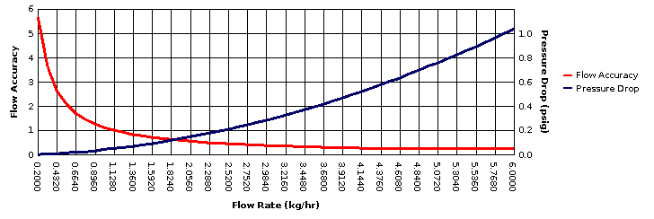
* All pressure drop and velocity results are based on the process conditions (except flow rate) that are entered in the Operating column.

